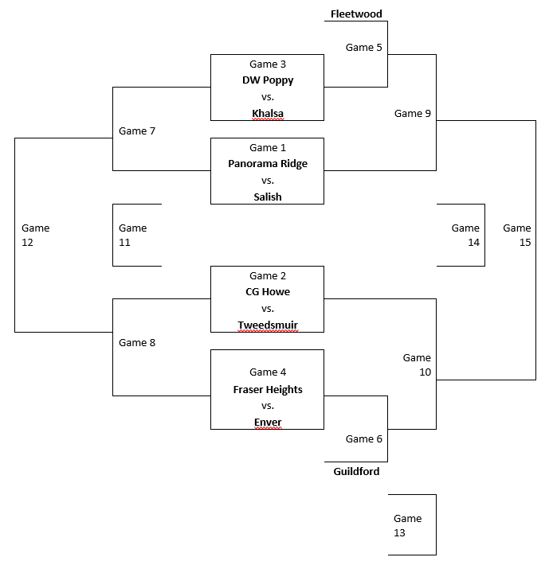
Thursday January 24
Game #1 – 10:00 Panorama Ridge vs Salish
Game #2 – 11:15 CG Howe vs Lord Tweedsmuir
Top team listed is the Home Team White
Game #3 – 12:30 DW Poppy vs Khalsa
Game #4 – 1:45 Fraser Heights vs Enver
Game #5 – 3:00 Fleetwood vs WG3
Game #6 – 4:15 WG4 vs Guildford

Friday January 25
Game #7 – 10:00 LG1 vs LG3
Game #8 – 11:15 LG2 vs LG4
Game #9 – 12:30 WG1 vs. WG5
Game #10 – 1:45 WG2 vs WG6

Saturday January 26
Game #11 – 9:00 LG7 vs LG8
Game #12 – 10:15 WG7 vs WG8
Game #13 – 11:30 LG5 vs. LG6
Game #14 – 12:45 LG9 vs. LG10
Game #15 – 2:00 WG9 vs. WG10

