Salish PHE Courses Grade 10 - 12

Active Living, Fitness, Athletics & Intramural Courses
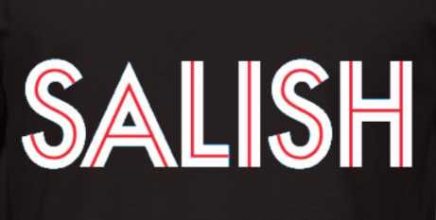
Active Living Athletics 10
Active Living 10 Credit

This is a specialized Active Living 10 course, designed to support our school Athletics program. Students in this class will learn to plan, organize, and officiate events in support of extra-curricular sports at Salish, with an emphasis on the fall and winter seasons (volleyball and basketball). An application is required to take this class,

Please see Mr. De La Paz for more information
Active Living 10
Active Living 10 Credit

Team / dual sports and activities; individual fitness; leadership development; social responsibility
Intramural Leadership 9 - 11

Linear X Block
Outside the Timetable
NOT A PHE CLASS
Leadership 10 Credit

This is a linear X Block course with classes running before school and at lunch.

This courses focus is on the organization & running of our school’s lunch time intramurals

An application is required to take this class, please see Mr. Sperling for more information
Active Community 11 / 12
Active Living 11 Credit
Active Living 12 Credit

This Active Living 11/12 course focuses on developing and implementing a positive, active culture within the community. Students will explore their creativity to plan, organize, and lead events that support the junior PHE classes at Salish, as well as with our K-7 feeder schools. An application is required to take this class,

Please see Mr. Pederson for more information
Fitness & Conditioning 11 / 12
Fitness & Conditioning 11 Credit
Fitness & Conditioning 12 Credit

Individual fitness; training, anatomy, nutrition, motivation, goal-setting.

Please see Ms. Riddoch for
more information
Active Living
11 & 12
Active Living 11 Class / Credit
Active Living 12 Class / Credit

Team / dual sports and activities; individual fitness; leadership development; social responsibility

